**QUESTION 1:**

Given an array of integers nums and an integer target, return indices of the two numbers such that they add up to target. You may assume that each input would have exactly one solution, and you may not use the same element twice.

**CODE:**

def two_sum(nums, target):

num_to_index = {}

for i, num in enumerate(nums):

complement = target - num

if complement in num_to_index:

return [num_to_index[complement], i]

num_to_index[num]=i

nums = [2, 7, 11, 15]

target = 9

print(two_sum(nums, target))

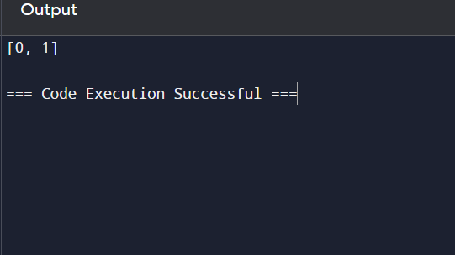

**RESULT:**

the program is executed successfully.

**QUESTION 2:**

You are given two non-empty linked lists representing two non-negative integers. The digits are stored in reverse order, and each of their nodes contains a single digit. Add the two numbers and return the sum as a linked list. You may assume the two numbers do not contain any leading zero, except the number 0 itself.

**CODE:**

class ListNode:

def __init__(self, val=0, next=None):

self.val = val

self.next = next

def addTwoNumbers(l1, l2):

dummy = ListNode()

current, carry = dummy, 0

while l1 or l2 or carry:

x = l1.val if l1 else 0

y = l2.val if l2 else 0

carry, out = divmod(x + y + carry, 10)

current.next = ListNode(out)

current = current.next

l1 = l1.next if l1 else None

l2 = l2.next if l2 else None

return dummy.next

def print_linked_list(node):

while node:

print(node.val, end=" -> " if node.next else "\n")

node = node.next

l1 = ListNode(2, ListNode(4, ListNode(3)))

l2 = ListNode(5, ListNode(6, ListNode(4)))

result = addTwoNumbers(l1, l2)

print_linked_list(result)

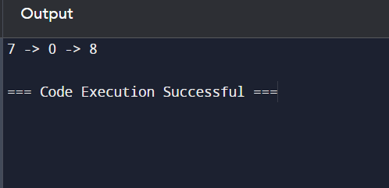

**RESULT:**

the program is executed successfully.

**QUESTION 3:**

Longest Substring without Repeating Characters Given a string s, find the length of the longest substring without repeating characters.

**CODE:**

def lengthOfLongestSubstring(s: str) -> int:

char_set = set()

left = 0

max_length = 0

for right in range(len(s)):

while s[right] in char_set:

char_set.remove(s[left])

left += 1

char_set.add(s[right])

max_length = max(max_length, right - left + 1)

return max_length

s = "abcabcbb"

print(lengthOfLongestSubstring(s))

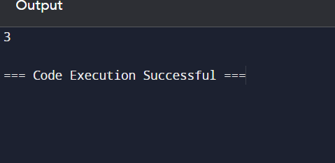

**RESULT:**

the program is executed successfully.

**QUESTION 4:**

Given two sorted arrays nums1 and nums2 of size m and n respectively, return the median of the two sorted arrays. The overall run time complexity should be O(log (m+n)).

**CODE:**

def findMedianSortedArrays(nums1, nums2):

if len(nums1) > len(nums2):

nums1, nums2 = nums2, nums1

m, n = len(nums1), len(nums2)

imin, imax, half_len = 0, m, (m + n + 1) // 2

while imin <= imax:

i = (imin + imax) // 2

j = half_len - i

if i < m and nums1[i] < nums2[j - 1]:

imin = i + 1

elif i > 0 and nums1[i - 1] > nums2[j]:

imax = i - 1

else:

max_of_left = max(nums1[i - 1] if i > 0 else float('-inf'),

nums2[j - 1] if j > 0 else float('-inf'))

if (m + n) % 2 == 1:

return max_of_left

min_of_right = min(nums1[i] if i < m else float('inf'),

nums2[j] if j < n else float('inf'))

return (max_of_left + min_of_right) / 2.0

nums1 = [1, 3]

nums2 = [2]

print(findMedianSortedArrays(nums1, nums2)) # Output: 2.0

nums1 = [1, 2]

nums2 = [3, 4]

print(findMedianSortedArrays(nums1, nums2))

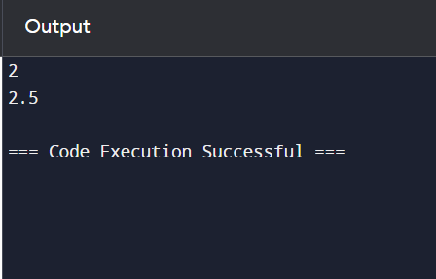

**RESULT:**

the program is executed successfully.

**QUESTION 5:**

Given a string s, return the longest palindromic substring in s.

**CODE:**

def longestPalindrome(s: str) -> str:

if not s:

return ""

def expandAroundCenter(left: int, right: int) -> str:

while left >= 0 and right < len(s) and s[left] == s[right]:

left -= 1

right += 1

return s[left + 1:right]

longest = ""

for i in range(len(s)):

longest = max(longest,

expandAroundCenter(i, i),

expandAroundCenter(i, i + 1),

key=len)

return longest

s1 = "MALAYALAM"

print(longestPalindrome(s1))

s2 = "12343"

print(longestPalindrome(s2))

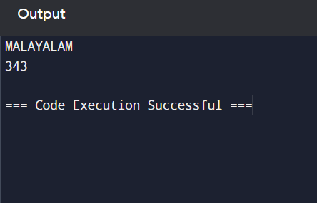

**RESULT:**

the program is executed successfully.

**QUESTION 6:**

The string "PAYPALISHIRING" is written in a zigzag pattern on a given number of rows like this: (you may want to display this pattern in a fixed font for better legibility)

**CODE:**

def convert(s: str, numRows: int) -> str:

if numRows == 1 or numRows >= len(s):

return s

rows = [''] * numRows

current_row, going_down = 0, False

for char in s:

rows[current_row] += char

if current_row == 0 or current_row == numRows - 1:

going_down = not going_down

current_row += 1 if going_down else -1

return ''.join(rows)

s = "PUNUGUPATIGUNASRI"

numRows = 3

print(convert(s, numRows))

numRows = 4

print(convert(s, numRows))

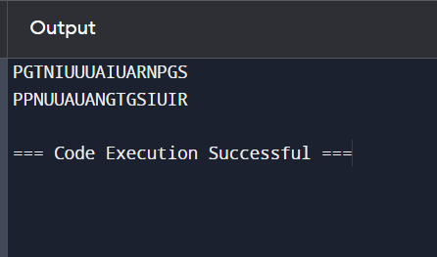

**RESULT:**

the program is executed successfully.

**QUESTION 7:**

Given a signed 32-bit integer x, return x with its digits reversed. If reversing x causes the value to go outside the signed 32-bit integer range [-231, 231 - 1], then return 0. Assume the environment does not allow you to store 64-bit integers (signed or unsigned).

**CODE:**

def reverse(x: int) -> int:

INT_MAX = 2**31 - 1

INT_MIN = -2**31

sign = 1 if x >= 0 else -1

x = abs(x)

result = 0

while x:

result = result * 10 + x % 10

x //= 10

if result > INT_MAX:

return 0

return sign * result

x = 123

print(reverse(x))

x = -123

print(reverse(x))

x = 120

print(reverse(x))

x = 1534236469

print(reverse(x))

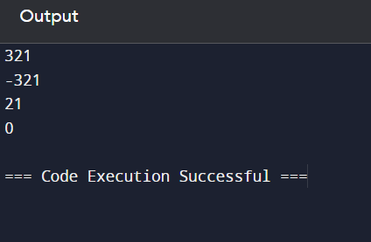

**RESULT:**

the program is executed successfully.

**QUESTION 8:**

Implement the myAtoi(string s) function, which converts a string to a 32-bit signed integer.

**CODE:**

def myAtoi(s: str) -> int:

INT_MAX = 2**31 - 1

INT_MIN = -2**31

s = s.strip()

if not s:

return 0

sign = 1

if s[0] in ('+', '-'):

sign = -1 if s[0] == '-' else 1

s = s[1:]

result = 0

for char in s:

if not char.isdigit():

break

result = result * 10 + int(char)

if result > INT_MAX:

return INT_MAX if sign == 1 else INT_MIN

return sign * result

s1 = "42"

print(myAtoi(s1))

s2 = " -42"

print(myAtoi(s2))

s3 = "4193 with words"

print(myAtoi(s3))

s4 = "words and 987"

print(myAtoi(s4))

s5 = "-91283472332"

print(myAtoi(s5))

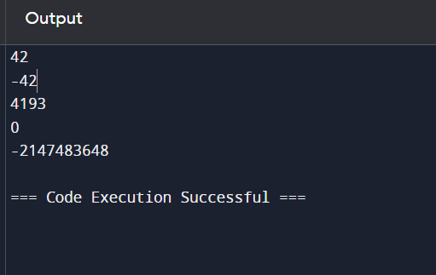

**RESULT:**

the program is executed successfully.

**QUESTION 9:**

Given an integer x, return true if x is a palindrome, and false otherwise.

**CODE:**

def isPalindrome(x: int) -> bool:

str_x = str(x)

return str_x == str_x[::-1]

x1 = 121

print(isPalindrome(x1))

x2 = -121

print(isPalindrome(x2))

x3 = 10

print(isPalindrome(x3))

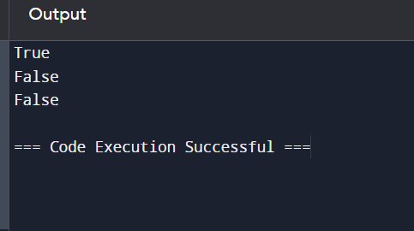

**RESULT:**

the program is executed successfully.

**QUESTION 10:**

Given an input string s and a pattern p, implement regular expression matching with support for '.' and '*' where: ● '.' Matches any single character. ● '*' Matches zero or more of the preceding element. The matching should cover the entire input string (not partial).

**CODE:**

def isMatch(s: str, p: str) -> bool:

m, n = len(s), len(p)

dp = [[False] * (n + 1) for _ in range(m + 1)]

dp[0][0] = True

for j in range(1, n + 1):

if p[j - 1] == '*':

dp[0][j] = dp[0][j - 2]

for i in range(1, m + 1):

for j in range(1, n + 1):

if p[j - 1] == '.' or p[j - 1] == s[i - 1]:

dp[i][j] = dp[i - 1][j - 1]

elif p[j - 1] == '*':

dp[i][j] = dp[i][j - 2] or (dp[i - 1][j] and (p[j - 2] == s[i - 1] or p[j - 2] == '.'))

return dp[m][n]

s1 = "aa"

p1 = "a"

print(isMatch(s1, p1))

s2 = "aa"

p2 = "a*"

print(isMatch(s2, p2))

s3 = "ab"

p3 = ".*"

print(isMatch(s3, p3))

s4 = "aab"

p4 = "c*a*b"

print(isMatch(s4, p4))

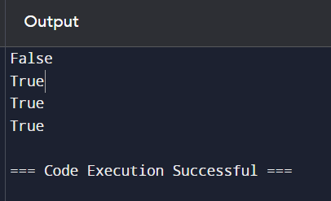

**RESULT:**

the program is executed successfully.